本课程颜色定制

屏幕取色器工具

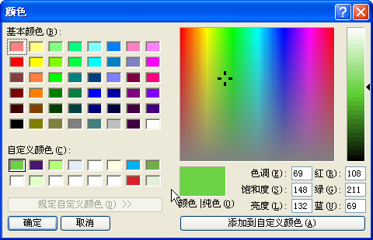

颜色分量RGB组、CSB色调饱和度组 [ 左-右、上-下 ]

[ 108,211,79 / 69,148,132 ]

[ 71,22,111 / 182,161,63 ]

[ 180,255,117 / 62,240,175 ]

[ 228,234,248 / 148,141,224 ]

[ 255,255,255 / 40,240,226 ]

[ 0,176,240 / 131,240,113 ]

[ 112,173,71 / 64,100,115 ]

[ 226,255,202 / 62,240,215 ]

[ 215,34,41 / 238,174,117 ]

[ 226,239,218 / 65,95,218 ]